

Geethanjali College of Engineering and Technology
(UGC Autonomous Institution Accredited by NBA & NAAC, Permanentl
Affiliated to JNTUH, ISO 9001:2015 certified) Cheeryal (V), Keesara (M), Medchal. Dist. 501301
Report on
IOT VERSE-2K23
Dated: 14th – `15th December 2023

Objective:
“IOT VERSE 2k23” is a two days event to 2nd and 3rd year students of Geethanjali College of Engineering and Technology conducted by IoT Club GCET. This day-1 first half Session featured educational guest lectures peer learning sessions On Internet of Things, and enjoyable learning activities. The second half idea pitching on various applications of Iot and Innovative solutions to various problems faced. Day-2 first half featured with project exhibition and second half was Quiz based on IOT.

Expected Outcome:
Students would learn the fundamentals of IOT through Quiz, and they will have the opportunity to create an independent project on IOT .Iotverse will assist students get interested in IOT and help them to see the professional opportunities that IOT may provide various domains like Healthcare, Smart Education, Smart Agriculture, Smart Homes etc.
Faculty coordinator: Ms. M. Alphonsa
Assistant Professor
CSE-IoT
Student Coordinator: GVNS Tejaswi (III-IoT)

Resource Person: Mr. Bharadwaj Arvapally Co-Founder, ABTechVille LLP
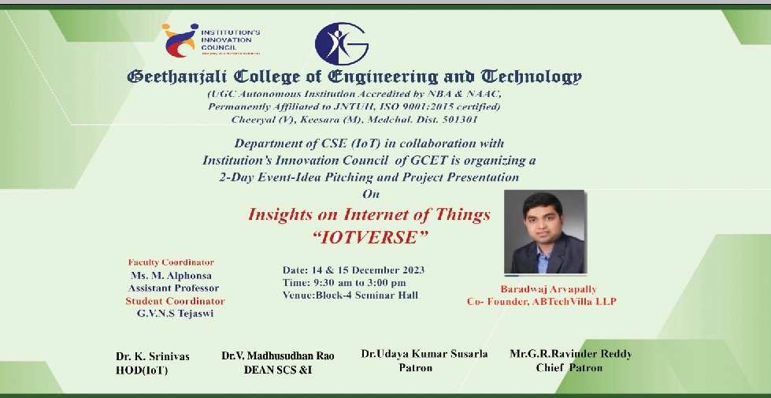

Session Plan:
Day-1: (14th December,2022)

S.No | Time | Session
1 | 9.30 am to 10.00 am | Inauguration Ceremony
2 | 10.00 am to 10.20 am | Chief guest speech
3 | 10.20 am to10.25 am | Guest lecture profile
4 | 10.25 am to 12.10 PM | Guest lecture
 | LUNCH
5 | 1.00 PM TO 3.00 PM | Idea pitching
6 | 3.10 pm to 3.15 pm | Prize winner
Day-2: (15th December,2022)

S.No | Time | Session
1 | 10.00 am to 12.20 am | Project exhibition
 | LUNCH
2 | 1.20 pm to 2.20 pm | Quiz
3 | 2.20 pm to 3.15 pm | Fun activities
4 | 3.15 pm to 3.20 | Prize distribution

Prize Winners:

  - Idea pitching:

S.No | Name | Roll No | Prize | Domain
1 | Manobhiram Bhavya Sree  M.Likith | 22R11A6601  22R11A6648  21A11A6336 | Winners | Education
2 | B.Akshaya Bhavani E.Manju M.Meenakshi | 22R11A6945  22R11A6249  22R11A6948  22R11A6955 | Runner up | Health care

  - Quiz:

S.no | Name | Roll No | Prize
1 | P.Sharmila P.Sathwik  R.Srivani | 22R11A6637  22R11A6636  22R11A6641 | Winners

Snapshots of the Event:

Day-1:

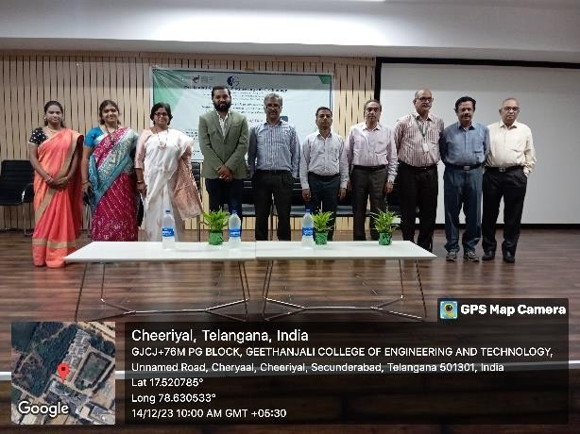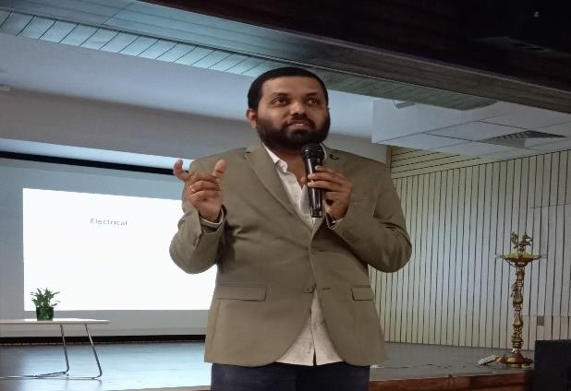
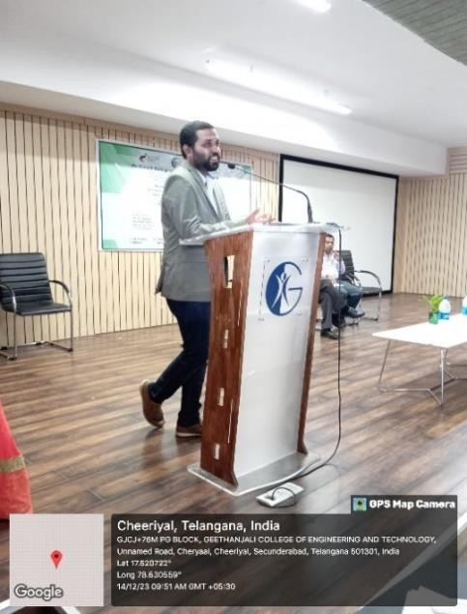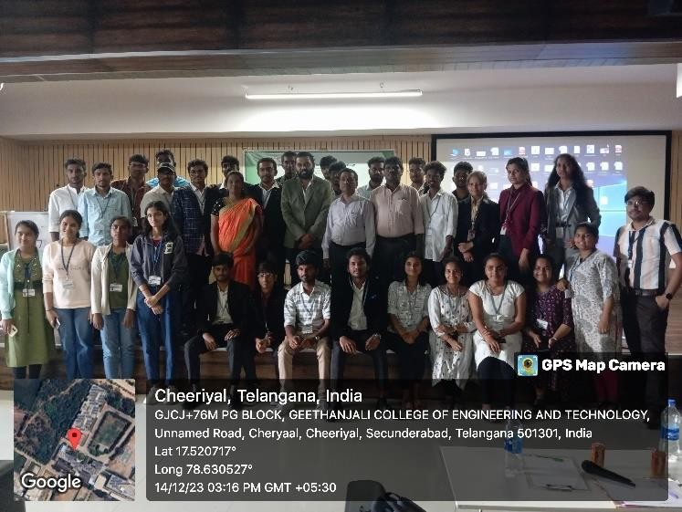
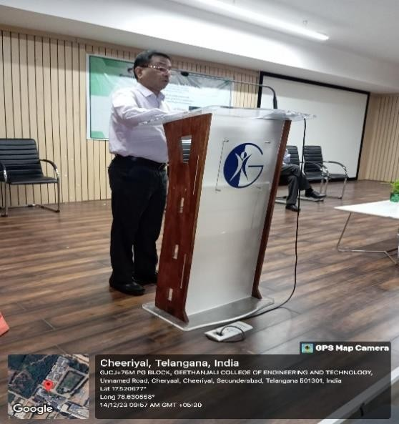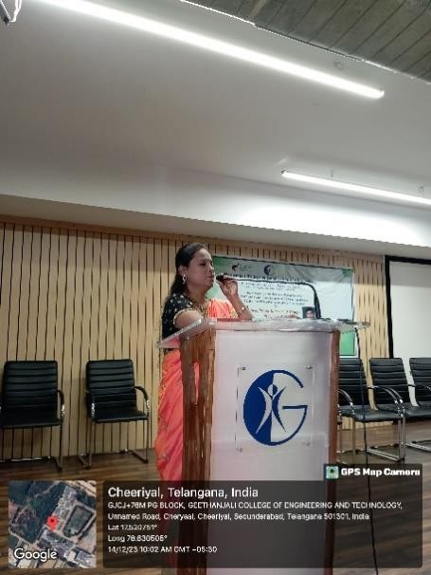

Day-2:

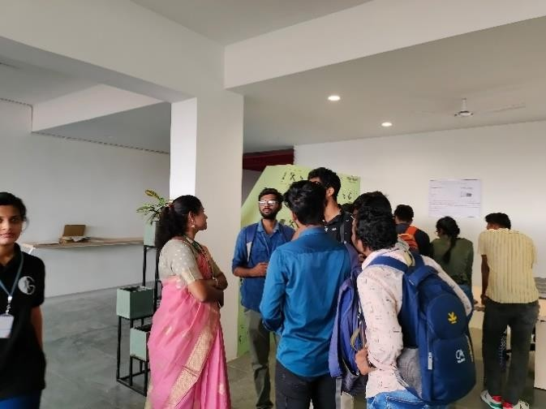 | 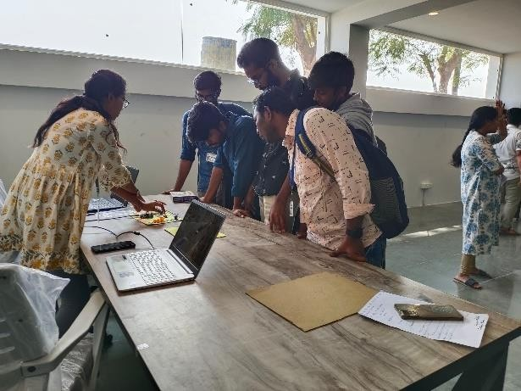

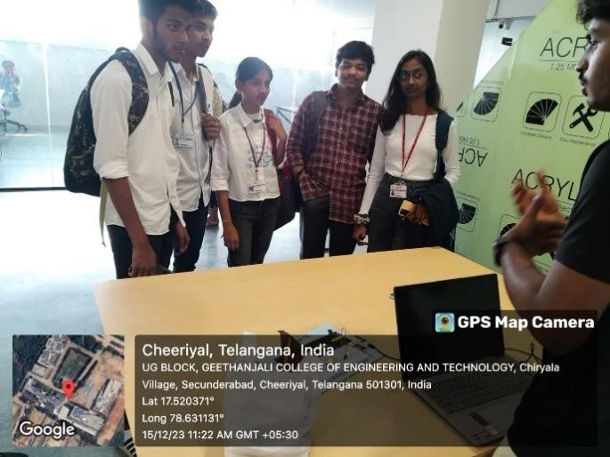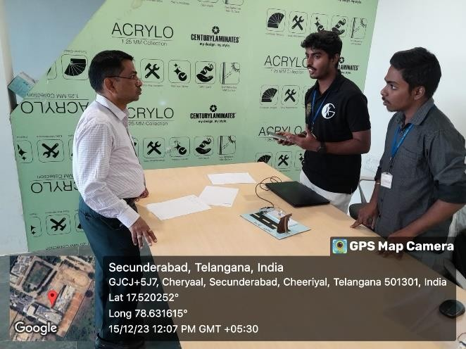
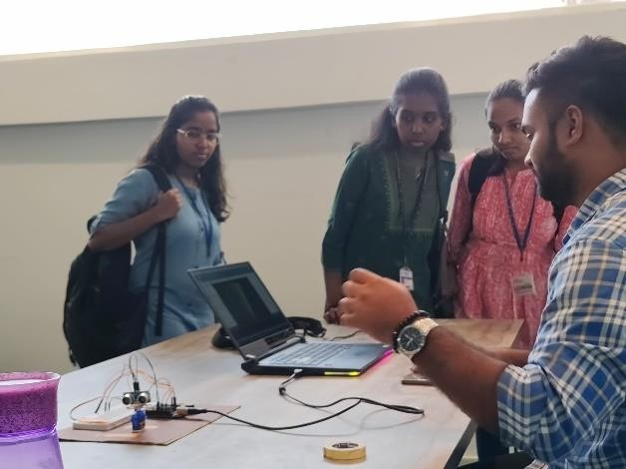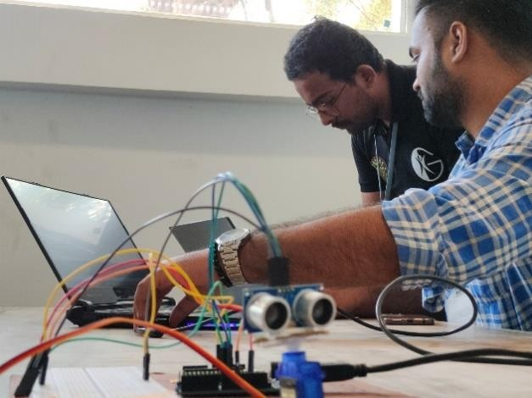

Winners:

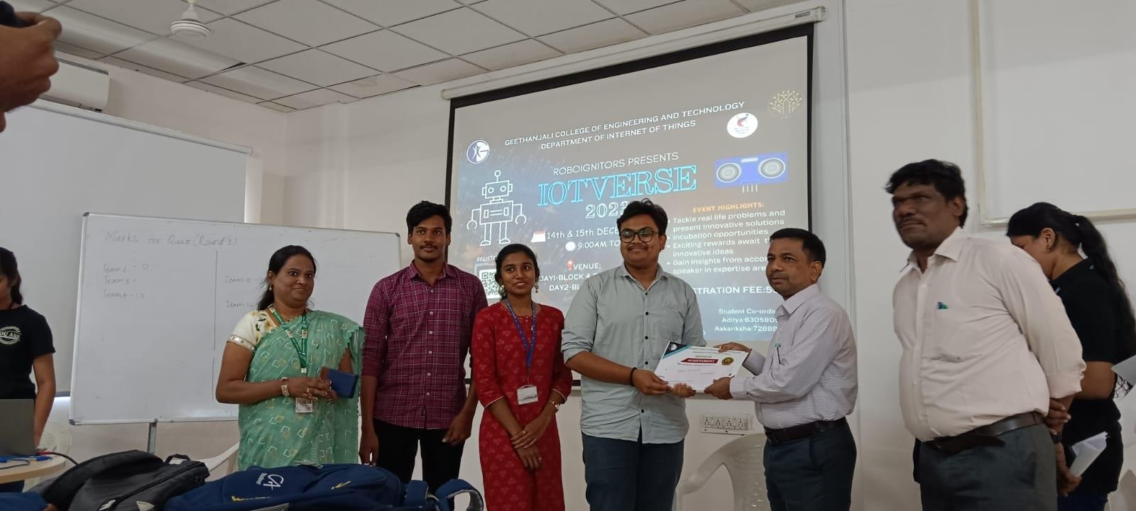
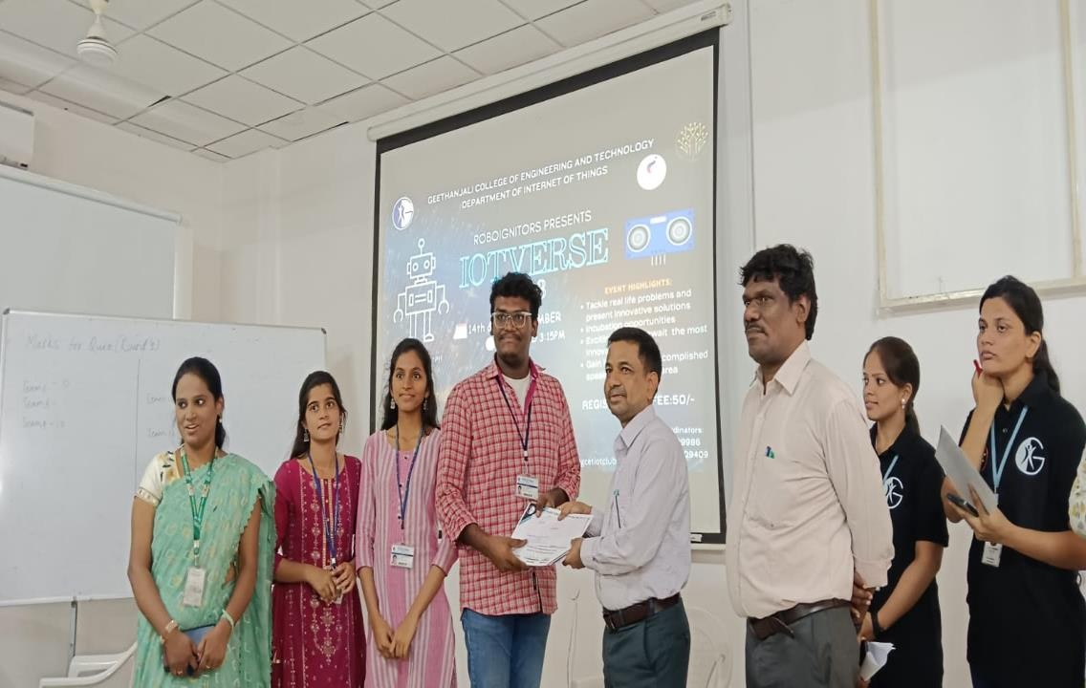

Links:

- Registration form: https://docs.google.com/spreadsheets/d/1Vq8PszLeQhguj0sH8eanyBSPAHg- slNx/edit?usp=sharing&ouid=107138937597089327870&rtpof=true&sd=true

